Q1.

Terminal 1:

Terminal 2:

Q2.

|  |  |
| --- | --- |
| //HAMZA UMER  //OS LAB 8 QUESTION 2 PART A  //writefirst.c  #include <stdio.h>  #include <string.h>  #include <fcntl.h>  #include <sys/stat.h>  #include <sys/types.h>  #include <unistd.h>  int main()  {  char write1[50], read1[50];  char * myfifo = "/tmp/myfifo";//FILEPATH OF PIPE  mkfifo(myfifo, 0777);//MAKING PIPE  while (1)  {//OPENING FIRST PIPE TO WRITE AND SEND TO SECOND PROCESS  int firstprocess = open(myfifo, O_WRONLY);  printf("\nYou are in First Process. Write Something: ");  fgets(write1, 50, stdin);  write(firstprocess, write1, strlen(write1)+1);  close(firstprocess);//CLOSING PIPE  firstprocess = open(myfifo, O_RDONLY);//OPEINING PIPE TO TAKE INPUT OF SECOND PROCESS  read(firstprocess, read1, sizeof(read1));  printf("Second Process: %s\n", read1);  close(firstprocess);//CLOSING PIPE  }  return 0;  } | //HAMZA UMER  //OS LAB 8 QUESTION 2 PART A  //writefirst.c  #include <stdio.h>  #include <string.h>  #include <fcntl.h>  #include <sys/stat.h>  #include <sys/types.h>  #include <unistd.h>  int main()  {  char write2[50], read2[50];  char * myfifo2 = "/tmp/myfifo";//FILE PATH OF PIPE  mkfifo(myfifo2, 0777);//MAKING PIPE  while (1)  {//READING THE CONTENT OF FIRST PROCESS    int secondprocess = open(myfifo2,O_RDONLY);//OPENING FIRST PIPE  read(secondprocess, read2, 50);  printf("FIRST PROCESS: %s\n", read2);  close(secondprocess);//CLIOSING PIPE  secondprocess = open(myfifo2,O_WRONLY);//OPENING SECOND PIPE TO WRITE AND SEND DATA TO FIRST PROCESS  printf("\nYou are in Second Process. Write Something: ");  fgets(write2, 50, stdin);  write(secondprocess, write2, strlen(write2)+1);  close(secondprocess);//CLOSING SECOND PIPE  }  return 0;  } |
|  |  |

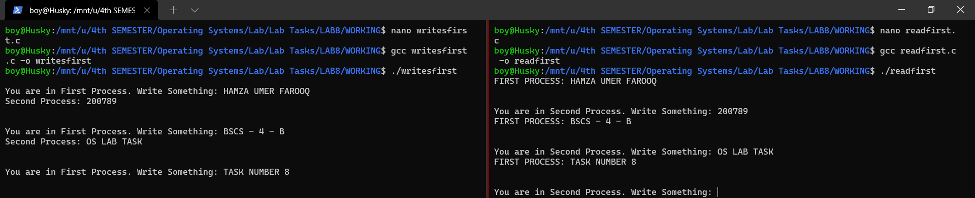

Q3.

